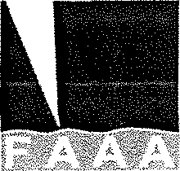
MEMBERSHIP APPLICATION AND DUES
(NEW) Membership Dues $150.00 Renewing Members $125.00

Name: Job Title:
Practice/Company:
Mailing Address: City: State: Zip:

Phone: E-mail:

PAYMENT OPTIONS: Check Enclosed for:

Payment Methods | Payee
Zelle | thefaaa2001@gmail.com
Credit Card | Please provide an email address for delivery of the invoice; You will pay this securely online via Chase – all credit cards accepted
Check** | FAAA (See address and contact below)

Email Address for invoice (if different): ________________________________________________

CREDIT CARD PAYMENT
Send completed membership form to Kelly Dennis at thefaaa2001@gmail.com

A statement will be sent to you and upon receipt of payment, the credit card statement will read “DB Healthcare Consulting”

**MAIL CHECKS TO:
Kelly Dennis, Secretary/Treasurer
Florida Anesthesia Administrators Association
P O Box 490447
Leesburg, FL 34749-0447

COMPLETE ONE FORM PER MEMBER
Phone: 352-787-7869
Email: thefaaa2001@gmail.com

